THE VIVEVE SOLUTIONS
Women worldwide are increasingly demanding nonsurgical treatments. However, there are a limited number of safe and effective technologies specifically designed for women’s intimate health. Viveve provides clinically proven, innovative, nonsurgical treatments to improve women’s intimate health.
The Viveve System delivers a single-session treatment to generate collagen and restore tissue. The dual mode VIVEVE TREATMENT COOLS AND PROTECTS THE SURFACE WHILE HEATING THE DEEPER TISSUE. The Viveve Treatment is both safe and effective.

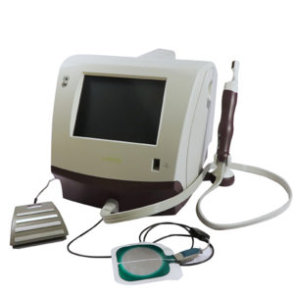

The Viveve System is a patented, cryogen-cooled monopolar, radiofrequency (RF) energy delivery system. Controlled-cooling protects the tissue surfaces from any damage and impacts the resistance of the epithelial layer which allows for greater penetration of the RF energy. RF consistently and safely delivers 90J/cm² of energy deep into the tissue.
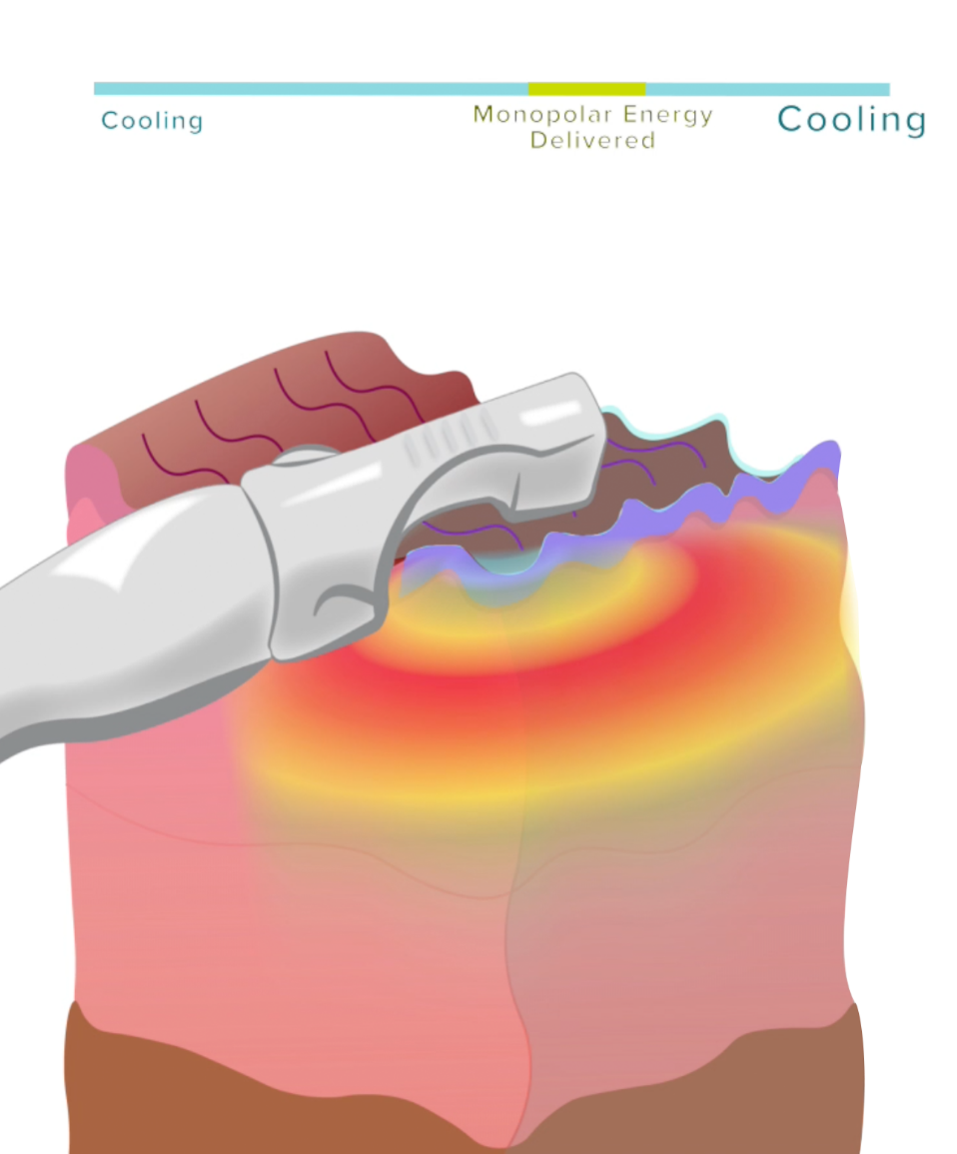

About the Treatment
The Viveve Treatment works via a small probe which emits cryogen-cooling to protect the tissue and radiofrequency waves to heat the tissue. This prompts the production of new collagen to reinvigorate the tissue

Benefits:
Safe, Comfortable, /clinically-proven, no Downtime
Non-surgical 30-45 min radiofrequency treatment
Rebuild Vaginal Tissues
Improves orgasm, lubrication and arousal
Decreases stress urinary leakage when you cough, laugh, sneeze or exercise

Please call us for Free private consultation at 720-667-4898

